
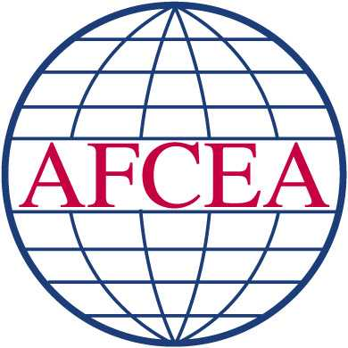

Tee, Pin & Prize Sponsorships Available!
AFCEA-North Carolina
Golf Tournament
Fall Fundraiser

only at
Proceeds benefit the AFCEA Scholarship Fund
Register today at www.afcea-nc.org
Fee: $70.00
Includes: Cart, green fees, dinner and door prizes

Format: Captain’s Choice
Check In: 11:00am
Shotgun Start: 12:00

Mulligans: 1/$5.00, 3/$10.00 (limit 3 per person)

String: 20ft., for $20
(limit 1 per team)

Free Drinks & Driving Range!

Participants Receive One Round of Golf for $25, Dicks Golf Coupons, PLUS 20% off on all Gates Four Merchandise!
November 1, 2013 – 12:00 PM Start
Gates Four Golf and Country Club
6775 Irongate Dr., Fayetteville, NC 28306
1, 2, 3 place cash awards, long drive and closest to pin Door prizes, too!

