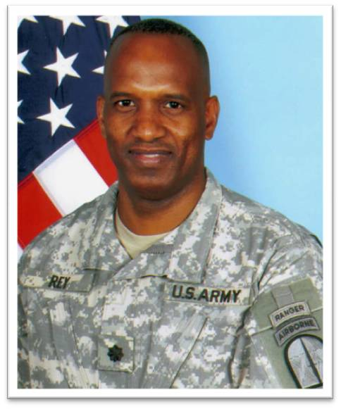
Lieutenant Colonel Jeth B. Rey
Commander of the 112th Signal Battalion (SO) (A)

Lieutenant Colonel Jeth B. Rey is the 112th Signal Battalion (Special Operations) (Airborne) Commander. The 112th Special Operations Signal Battalion provides simultaneous dedicated theater-level signal support to six theaters, their Joint Task Force Commands and their subordinate headquarters, and other commands as required; also, provide Network Operations (NETOPS) for U.S. Army Special Operations Command (USASOC) and its subordinate units and provide USSOCOM alternate GNCC.

Lieutenant Colonel Jeth B. Rey enlisted in the Army in September 1983. After completing Basic Training at Fort Dix and AIT at Ft Gordon, he was assigned to HHC 2nd BDE Camp Hovey, Korea as a combat signaler. As he progressed through the enlisted ranks over the next 8 years, he served in various positions of leadership in 4th PSYOP Group and 8th PSYOP Battalion at Fort Bragg, North Carolina; C Co 3/7th SFG (A) at Fort Sherman, Panama; A Co 112th Signal Battalion at Fort Bragg, North Carolina (during its inception) and 3rd Battalion 75th Ranger Regiment at Fort Benning, Georgia.

LTC Rey is a graduate of the Warrant Officer Candidate School and has served as a 250A Communications Security Technician and 250N Switching Systems Technician Warrant Officer at 3rd Battalion 75th Ranger Regiment (Airborne), Fort Benning, Georgia.

LTC Rey received his commission from the Army Officer Candidate School (OCS) and graduated as the Distinguished Honor Graduate. Upon graduation he was commissioned into the U.S. Army Signal Corps in 1996. He is a graduate of the Signal Officer Basic Course (1997), the Signal Captains Career Course (2000), and the Naval War College Command and General Staff College (2007). LTC Rey holds a Master’s Degree in Telecommunications Management from Webster University (2002) and a Master's Degree from the Naval War College in National Security and Strategic Studies (2007).

LTC Rey’s previous assignments include Commander of the White House Communications Agency, Special Missions Command, Camp David Presidential Retreat (2010-2012); Signal Squadron Commander, United States Army Special Operations Command Fort Bragg, North Carolina (2007-2010); Signal Squadron Operations Officer, United States Army Special Operations Command Fort Bragg, North Carolina (2005-2006); Alpha Company Commander, 112th Signal Battalion Special Operations (Airborne), Fort Bragg, North Carolina (2004-2005); Signal Squadron Executive Officer, United States Army Special Operations Command Fort Bragg, North Carolina (2002-2004); Tactical Communications Troop Commander, United States Army Special Operations Command Fort Bragg, North Carolina (2000-2002); Communications Officer for the Combatant Commander at the United States Southern Command, Quarry Heights, Panama/Miami, Florida (1997-2000); and Signal Officer 3rd Battalion 75th Ranger Regiment (Airborne), Fort Benning, Georgia (1996).
LTC Rey’s badges include the Ranger Tab, Master Parachutist Badge, Pathfinder Badge, and Presidential Service Badge. His awards include the Bronze Star Medal (one oak leaf Cluster), Defense Meritorious Service Medal (two oak leaf clusters), Meritorious Service Medal (two oak leaf clusters), Joint Service Commendation Medal (one oak leaf Cluster), Army Commendation Medal (six oak leaf clusters), Joint Service Achievement Medal, and Army Achievement Medal (eleven oak leaf clusters).
LTC Rey is married to COL (Dr.) Carla Long from Carson, California. He has one son Jeth II (15). LTC Rey’s hobbies are running, swimming, biking and spending time with his family.

